The Islamia University of Bahawalpur

Department of Information Technology


Software Design Description

(SDD Document)

For

<Blood Management System>

By

Nimra Afzal

F22NINFT1M01040

Session 2022-2026

Supervisor

Mr.Faisal Shahzad

Introduction

The Blood Management System (BMS) is a web-based application designed to manage blood donation, storage, and distribution efficiently. The system helps hospitals, blood banks, donors, and patients by maintaining accurate records of blood availability and ensuring timely blood supply.

Core Modules:

User Management (Admin, Donor, Hospital/Patient)

Blood Donor Management

Blood Inventory Management

Blood Request & Approval

Admin Dashboard

Notification System

Design Methodology and Software

Process Model

Design Methodology

The system follows Object-Oriented Programming (OOP) methodology.

Justification:

Entities like Donor, BloodUnit, Request, and User can be modeled as objects.

Ensures modular, reusable, and scalable system design.

Easy maintenance and future expansion.

Software Process Model

The Agile Software Development Model is used.

Justification:

Supports incremental development.

Allows continuous feedback from hospitals and blood banks.

Suitable for real-world healthcare systems with evolving requirements.

System Overview

The Blood Management System enables:

Donors to register and donate blood.

Blood banks to manage blood stock.

Hospitals/patients to request blood.

Admin to monitor and control the entire system.

Key Functionalities:

Donor Features:

Register and login

View donation history

Receive donation reminders

Hospital/Patient Features:

Request blood

Track request status

View available blood groups

Admin Features:

Manage donors and users

Approve/reject blood requests

Monitor blood inventory

Generate reports

Architectural Design

Modular Program Structure

User Management Module

Registration, login, authentication

Role-based access (Admin, Donor, Hospital)

Donor Management Module

Donor details

Blood donation records

Blood Inventory Module

Blood group-wise stock

Expiry date tracking

Blood Request Module

Blood request submission

Approval and rejection

Admin Dashboard Module

System monitoring

Report generation

Notification Module

SMS/Email alerts for donors and hospitals

System Architecture

The system follows a Multi-Tier Architecture:

Presentation Layer

Web interface for users and admin

Business Logic Layer

Processes blood requests

Validates donation and inventory rules

Data Layer

Stores donor, blood stock, requests, and user data

Process Flow / Representation

User Login

Select Role (Donor / Hospital)

Donor:

Register donation

Blood added to inventory

Hospital/Patient:

Request blood

Admin:

Verify availability

Approve or reject request

Blood issued

Inventory updated

Notification sent

FlowChart
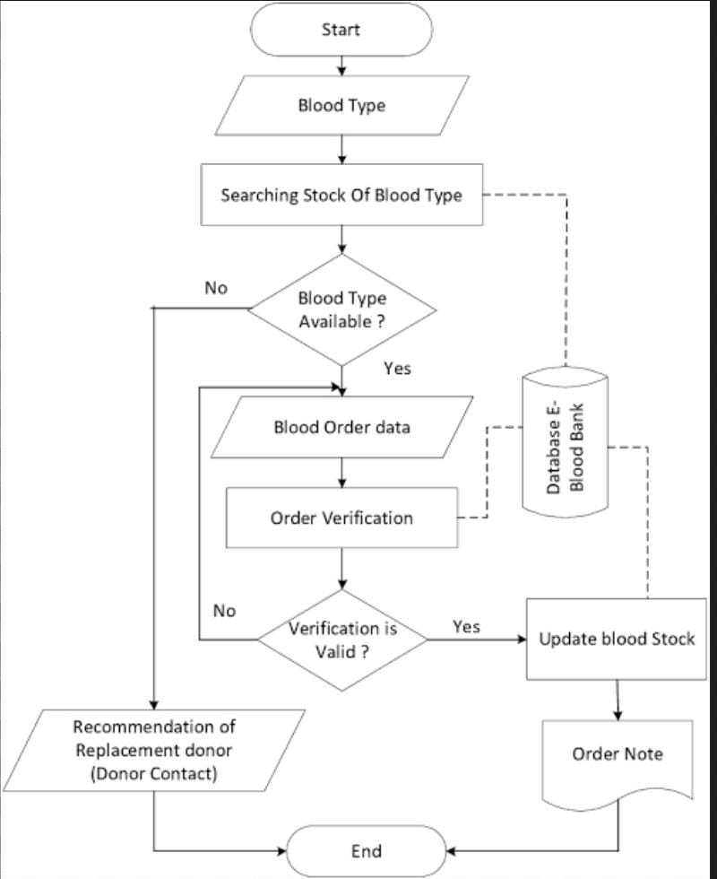

Design Models

Class Diagram (Main Classes):

User

Donor

BloodUnit

BloodRequest

Admin

Hospital

Relationships:

User ↔ Donor (One-to-One)

Donor ↔ BloodUnit (One-to-Many)

BloodRequest ↔ BloodUnit (Many-to-One)

Admin ↔ BloodRequest (One-to-Many)

Sequence Diagram (Blood Request Flow)

Hospital submits blood request

System checks blood availability

Admin verifies request

Blood issued

Request status updated

Notification sent

State Transition Diagram (Blood Request)

Requested

Approved

Issued

Rejected

Completed

Data Design

Major Entities:

Donor

DonorID, Name, BloodGroup, Contact, LastDonationDate

BloodUnit

BloodID, BloodGroup, Quantity, ExpiryDate

BloodRequest

RequestID, BloodGroup, Quantity, Status, RequestDate

User

UserID, Username, Password, Role

Data Dictionary (Summary)

BloodUnit

BloodID (Integer)

BloodGroup (String)

Quantity (Integer)

ExpiryDate (Date)

Methods:

addBlood()

updateStock()

removeExpiredBlood()

Algorithm & Implementation

Blood Request Algorithm:

IF requested blood group is available

IF quantity is sufficient

Approve request

Update inventory

Notify hospital

ELSE

Reject request

ELSE

Reject request

Software Requirements Traceability Matrix

Req No Requirement Design Component

FR01 User Login User Class

FR02 Donor Registration Donor Class

FR03 Blood Inventory BloodUnit Class

FR04 Blood Request BloodRequest Class

FR05 Request Approval Admin Class

Human Interface Design

User Interfaces:

Login & Registration Forms

Blood Availability Dashboard

Blood Request Form

Admin Control Panel

Feedback:

Success messages (Request Approved)

Error messages (Blood Not Available)

Notifications via Email/SMS

Conclusion

The Blood Management System provides an efficient, secure, and reliable solution for managing blood donations and distribution. It improves coordination between donors, blood banks, and hospitals, ultimately saving lives.

